Estimation of networks of bilateral exposures with incomplete data

In an increasingly interconnected world it becomes ever more important to measure interconnectedness, especially for contagion analysis. Full information is, however, often not available or not available in a timely manner. Reconstructing networks from partial data is therefore one of the most important yet challenging tasks in network studies.

In the past, many contagion studies[1] lacked precise information on bilateral interbank exposures and had to rely on assumptions, such as for instance the maximum entropy (ME) principle, which might be the reason why little contagion was found. Assuming maximum entropy implies that the interbank assets and liabilities are distributed evenly between all the possible counterparts. This, in turn, implies a good deal of diversification on the lending and funding structures of the banks which participate on the interbank market. Recognizing this, Mistrulli (2011) estimates the losses of the system with two different networks: one generated by using maximum entropy versus one generated with real exposures and concludes that the ME assumption causes an underestimation of contagion risk. Figure 1 provides a graphical representation of this line of analysis.

**Figure 1**

|  |  |
| --- | --- |
| a) Real exposures network | b) ME generated exposures network |

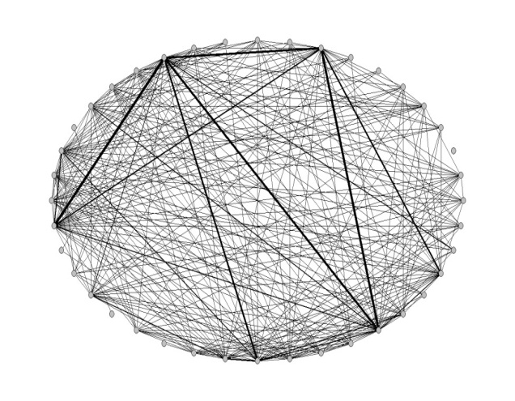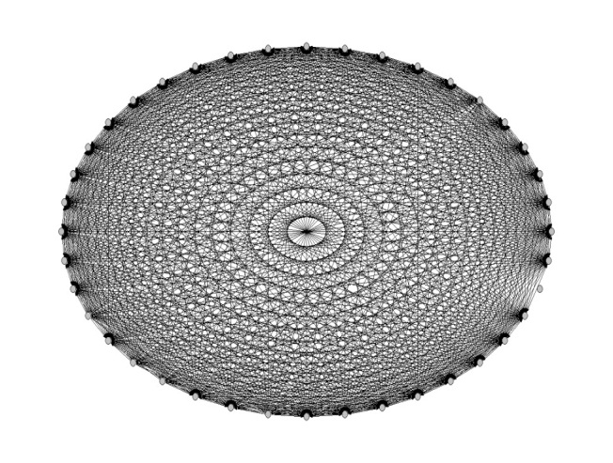

Source: Batiz-Zuk et al (2013). The authors show two different networks: one generated under the ME principle and one with real exposures data.

Some financial authorities are able to construct the real network of bilateral exposures for one or more markets without having to make any sort of assumptions. Amongst these are Brazil, Germany, Italy, Korea, Mexico, and the Netherlands. Given these real data, the aim is to benchmark several of the many approaches proposed in the literature to overcome the limitations of the maximum entropy approach.

Currently we have identified the approaches listed in Table 1 to be included in the exercise. The majority of the codes is in Matlab.

Table 1 Provisional overview of the approaches to be included

|  |  |  |  |  |
| --- | --- | --- | --- | --- |
| Author | Parameter Choice | Additional Info | Code Received and Lanuage | Responsible |
| Anand et al (2014) | Lambda |  | Yes, Matlab | Kartik |
| Baral and Fique (2012) |  |  | Yes, Matlab | Dilyara |
| De Masi et al (2006) |  |  | No | Serafin |
| Mastromatteo, et al (2012) | Lambda |  | Yes, C++ | Kartik |
| Moussa (2011) | ?? | ?? | No | Iman |
| Musmeci et al (2013) | ?? | ?? | No |  |
| Halaj and Kok (2013) | Probability map |  | Yes, Matlab | Grzegorz |
| Halaj and Kok (2014) | Probability map | Bank level information | No, Python | Grzegorz |
| Drehman and Tarashev (2014) |  |  | No, Matlab | Iman |
| Battiston et al () |  |  |  | Ib |

Note: This table is still under developments as not all approaches and codes have been studies or received.

The approaches to be included differ as to the required information and in the assumptions made in order to generate bilateral exposures given aggregated balance sheet data (ie marginal). Because of these differences we do not take a view on any of the approaches; instead, we present them to the reader who can then decide on the most appropriate approach given her specific circumstances.

The LST Network group will coordinate the horse race to guarantee maximum efficiency and comparability. As the process chart in Appendix A shows, the algorithms will be made to fit a shared variable naming convention (Iman to formulate this) and a common script to collect the description of the output matrices (Serafin working on the Matlab code for this). Currently it seems that the most of code can be employed with relatively limited knowledge of Matlab. Moreover, the rightmost column of Table 1 shows the go-to person to provide help in running the codes.

As currently envisaged the code will be shared, not the data. The networks solicited can be any relevant network available. Although the fit of the algorithms might change over time, the comparison will currently target just a single slice of the network. Each contributor is free to choose the most relevant period. Currently BR, DE, FR, MEX, NL and TW have agreed to contribute or to investigate possible participation.

The deliverable of this project would be an overview and a discussion of the relative performance of several of the most used algorithms on several countries’ networks.

Question 1 Would you be willing to participate? This would imply:

1. Prepare a suitable network data set

- Stays at your institution, in whatever format

2. Run as many of the algorithms as feasible

- Mostly Matlab, input and output will be standardized as much as possible

3. Prepare a write up of the results as input to the ‘horse race’ section

# References

Anand, K., B. Craig, G. von Peter (2014), “Filling in the blanks: network structure and interbank contagion”, Discussion Paper No 02/2014, Deutsche Bundesbank.

Baral, P., J. P. Fique (2012) “Estimation of Bilateral Connections in a Network: Copula vs. Maximum Entropy”, Mimeo.

De Masi, G., G. Iori, and G. Caldarelli (2006) “Fitness model for the Italian interbank money market” Phys. Rev. E 74, 066112 –December 2006 .

Upper, C. (2011) “Simulation methods to assess the danger of contagion in interbank markets“ Journal of Financial Stability, Volume 7(3), 111-125.

Halaj, G., C. Kok (2013). “Assessing Interbank contagion Using Simulated Networks”, Working Paper No. 1506, January 2013, European Central Bank.

Halaj, G., C. Kok (2014). “Modeling Emergence of the Interbank Networks”, Working Paper No. 1646, March 2014, European Central Bank.

Mastromatteo, I., Zarinelli, E., Marsili, M., (2012) “Reconstruction of Financial Networks for Robust Estimation of Systemic Risk”, Journal of Statistical Mechanics Theory and Experiment 03/2012; March 2012.

Moussa, A., (2011), “Contagion and Systemic Risk in Financial Networks”, PhD Thesis, Columbia University.

Musmeci, N., S. Battiston, G. Caldarelli, M. Puliga, A. Gabrielli, (2013) “Bootstrapping Topological Properties and Systemic Risk of Complex Networks Using the Fitness Model”, Journal of Statistical Physics, May 2013, Volume 151 (3-4) 720-734.

# Annex A Process map

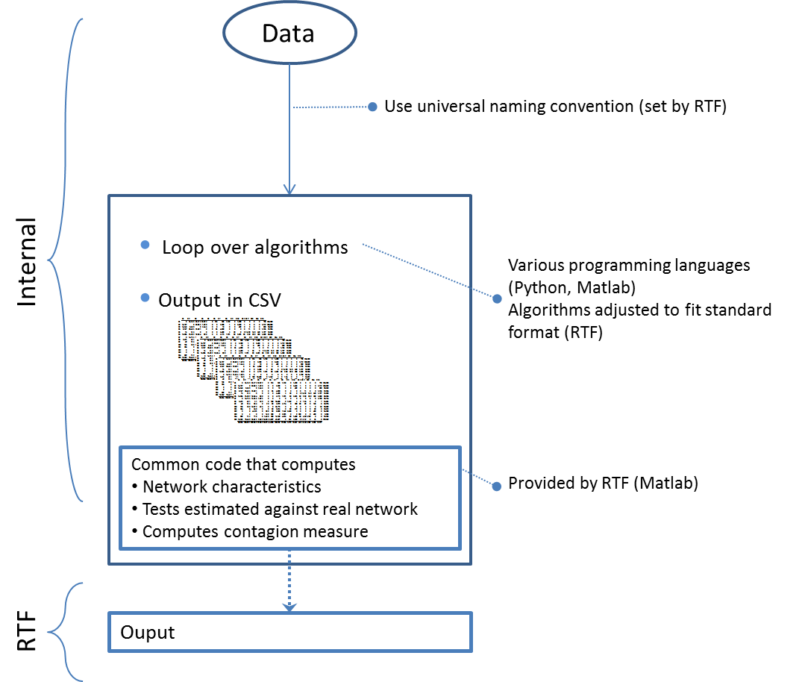

1. See Upper (2011) for a comprehensive summary of such studies.